A.V.KAVERI,
192512188.
EXPERIMENT NO. 4
DESIGN AND IMPLEMENTATION OF EDGE–CLOUD SYNCHRONIZATION USING LOCAL MQTT BRIDGE (GOOGLE COLAB VERSION)
Aim
To simulate Edge–Cloud synchronization by collecting IoT sensor data at an edge device, synchronizing it to the cloud, and performing real-time analytics using Python in Google Colab.
Objectives
- Simulate an Edge Device.
- Generate real-time IoT sensor data.
- Synchronize data from Edge to Cloud.
- Store synchronized cloud data.
- Perform stream analytics.
- Detect abnormal conditions.
- Visualize synchronized data.
Software required
- Google Colab
- Python 3
- pandas
- numpy
- matplotlib
Theory
- Edge Computing processes data close to the IoT device, reducing latency.
- Cloud Computing stores and analyzes synchronized data for long-term monitoring.
Data Flow:
IoT Device
↓
Edge Device
↓
MQTT Bridge (Simulation)
↓
Cloud Storage
↓
Dashboard

Scenario
- Smart Water Tank Monitoring
- Edge Device collects water level.
- Cloud stores synchronized values.
- Alert generated if water level is very low.
Algorithm
- Start Program.
- Generate Water Tank Level.
- Store data in Edge Memory.
- Synchronize data to Cloud.
- Calculate Mean.
- Calculate Moving Average.
- Calculate Standard Deviation.
- Detect Low Water Level.
- Display Graph.
- Save CSV.
Google colab code
import random
import pandas as pd
import numpy as np
import matplotlib.pyplot as plt
from IPython.display import clear_output
import time
edge_storage = []
cloud_storage = []
time_data = []
for i in range(1,51):
water_level = random.randint(10,100)
# Edge Storage
edge_storage.append(water_level)
# Synchronize to Cloud
cloud_storage.append(water_level)
time_data.append(i)
mean = np.mean(cloud_storage)
std = np.std(cloud_storage)
if len(cloud_storage)>=5:
moving=np.mean(cloud_storage[-5:])
else:
moving=mean
if water_level<20:
status="LOW WATER LEVEL"
else:
status="NORMAL"
clear_output(wait=True)
print("=========== EDGE DEVICE ===========")
print("Current Water Level :",water_level,"%")
print("Stored at Edge :",len(edge_storage))
print()
print("=========== CLOUD ===========")
print("Cloud Records :",len(cloud_storage))
print("Mean :",round(mean,2))

print("Moving Average :",round(moving,2))
print("Standard Deviation :",round(std,2))
print("Status :",status)
plt.figure(figsize=(10,4))
plt.plot(time_data,cloud_storage,marker='o')
plt.axhline(20,color='red',linestyle='--',label='Critical Level')
plt.xlabel("Sample")
plt.ylabel("Water Level (%)")
plt.title("Edge–Cloud Synchronization")
plt.legend()
plt.grid(True)
plt.show()
time.sleep(0.5)
df=pd.DataFrame({
"Sample":time_data,
"Water Level":cloud_storage
})
df.to_csv("cloud_water_data.csv",index=False)
print("Experiment Completed Successfully")
OUTPUT
=========== EDGE DEVICE ===========
Current Water Level : 18 %
Stored at Edge : 32
=========== CLOUD ===========
Cloud Records : 32
Mean : 54.81
Moving Average : 29.20
Standard Deviation : 21.65
Status : LOW WATER LEVEL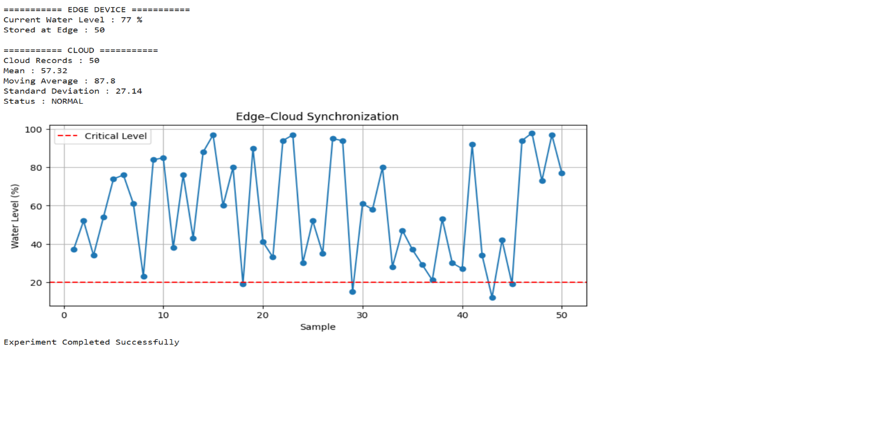
Result
The edge device successfully collected water level data and synchronized it with the cloud. The cloud performed stream analytics using Mean, Moving Average, and Standard Deviation, detected low water level conditions, and stored the synchronized data for future analysis.

